**Model calibration and Uncertainty analysis with PEST(++)**

**Exercise**

**Evaluation of the effectiveness of a hydraulic barrier**

DRAFT_02

2021-06-25

*Disclaimer*

*Even if the geological context described in the present exercise is real, all data concerning contamination are fictitious and have the only purpose to be used in the exercise. The sources, plume extension and the site contamination history are not real.*

*Acknowledgments*

*We wish to thank Milano Santa Giulia SPA and STID srl for the permission to use site specific data collected in the new Milan neighbor Santa Giulia, still under contruction.*

Contents

1 INTRODUCTION 6

2 GEOLOGICAL CONTEXT 6

2.1 Classification of subsoil units 6

2.2 General piezometric features 10

2.3 The site 11

2.4 Planned hydraulic barrier 15

3 NUMERICAL MODEL 18

3.1 Aim of the model 18

3.2 Tools used 19

3.3 Definitions of the study domain 19

3.4 Initial parameters assigned 22

3.5 Boundary conditions 26

3.6 Flow Model calibration 28

3.7 XXX 28

3.8 Transport Model calibration 28

4 CONCLUSIONS 29

5 REFERENCES 30

NOTES for RUI

Measurements of head and PCE concentration in September 2019, **Target_L1_sept2019_head_PCE.shp**

**Z_ToC_masl = elevation of the top of well case, m asl**

**GW_Depth_m = depth to water from the top case in m**

**GW_masl = head in m asl**

**PCE = concentration of Tetrachlorethylene in µg/l**

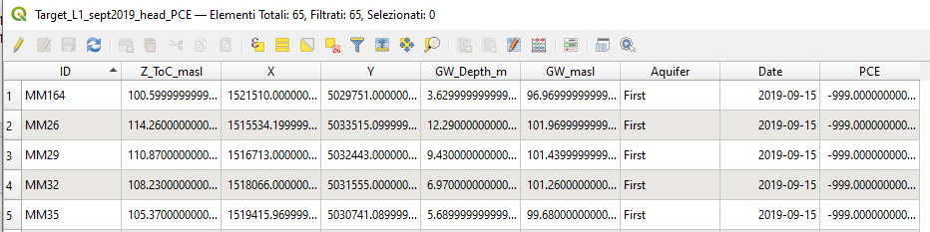

Chemical data were produced running the transport model with a “fictitious” reality, including 2 sources, **real_unknown_sources.shp**.

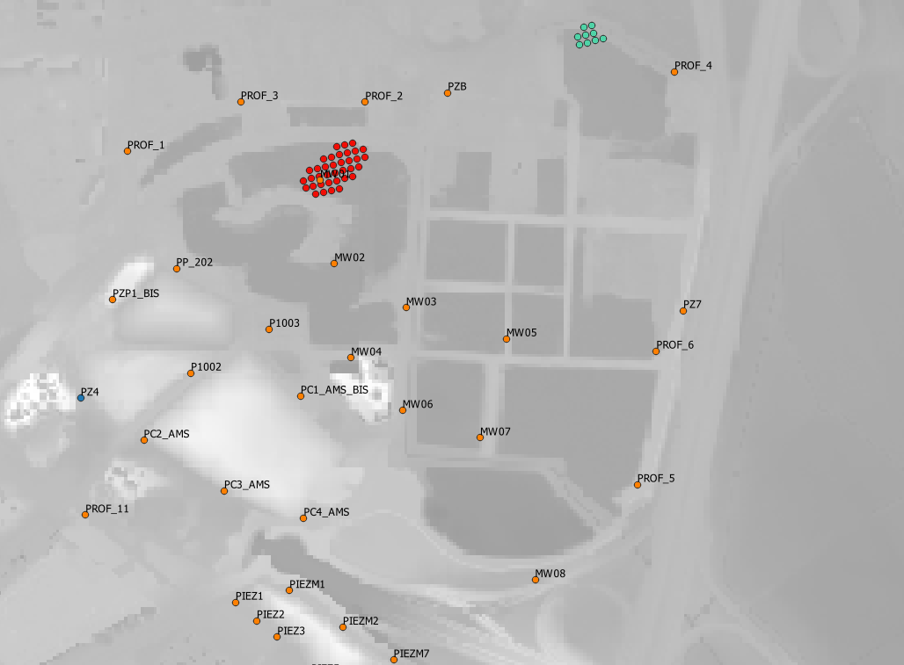

Orange = piezometers with h and PCE data; Blue = piezometers with only h data; Red= source reach 1; Green = source reach 2

Source 1 has been “seen” by a monitoring well, while source 2 is there but no one suspects its existence. Piezometers starting with “MW” are new and drilled after the discovery of source 1.

The “real” distribution of the contamination looks like this:

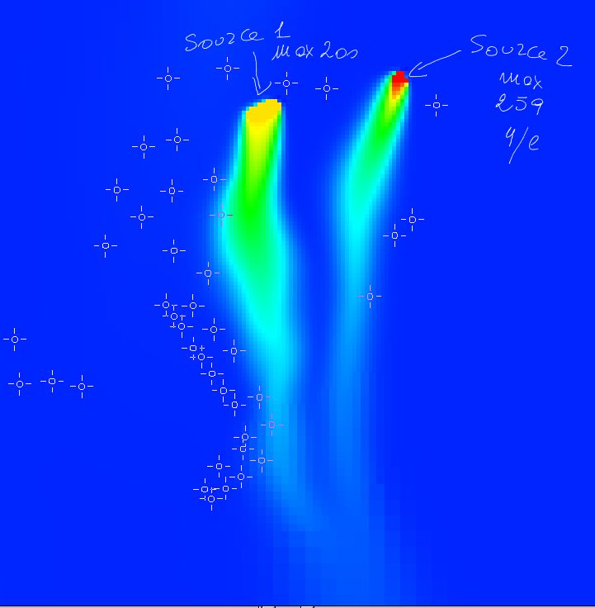

Based on these settings and the k field below.

Steady state

Time for transport: 1576800000 seconds = 50 years

4 time steps

Dispersivity L/T = 30/3

No reaction, no decay

Diffusion coefficient PCE = 1.02E-9 m2/s

<https://dtsc.ca.gov/wp-content/uploads/sites/31/2018/01/pce.pdf>

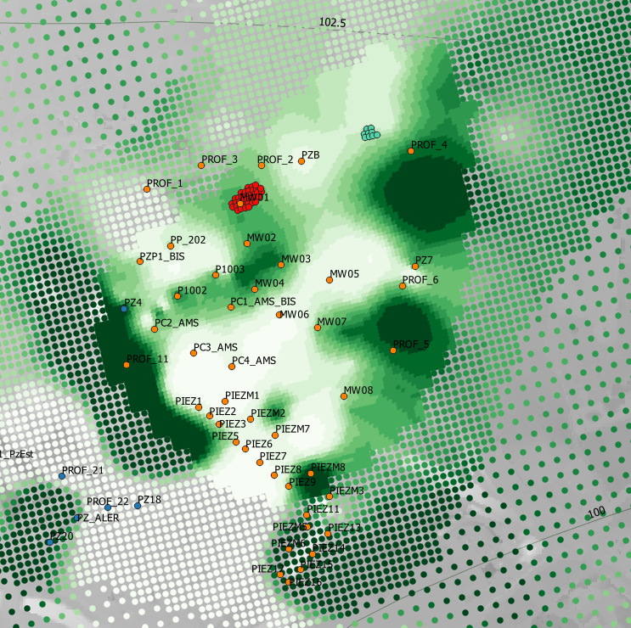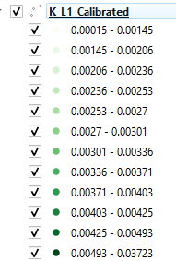

Initial PP values: **PP_kx_L1.shp**

# INTRODUCTION

The project area is located in the Lombard plain, in the municipal area of Milan, at an average topographical altitude of about 124 m asl.

The morphological structure of the territory consists of extensive fluvioglacial and fluvial plains of the Quaternary age, with a sub-flat morphology, without significant morphological differences in height, with weak slopes towards S of the order of 0.2-0.3%; the intense general urbanization has modified the original structure of the plain, making indistinguishable characters and morphological elements that are not in themselves evident (paleoalvei, terrace edges). The project area is inserted in the urban context of the municipal area, in which there are residential areas, offices, commercial areas and numerous infrastructures of public interest (railway stations, underground lines, public administration offices, schools, etc.).

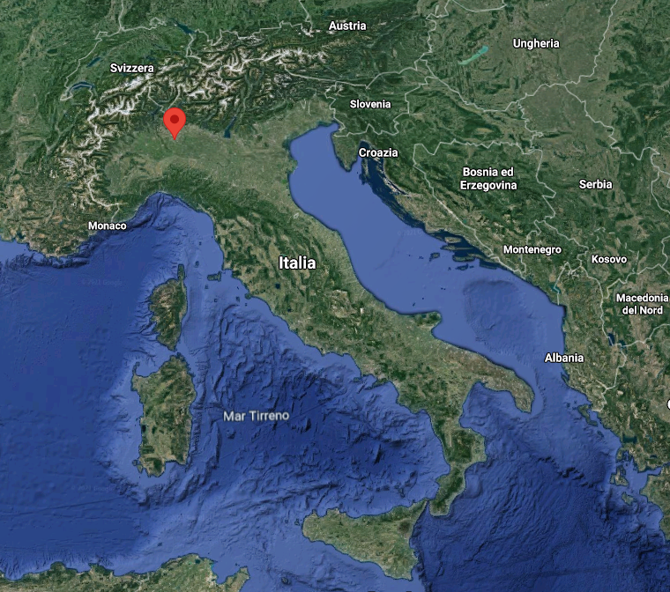 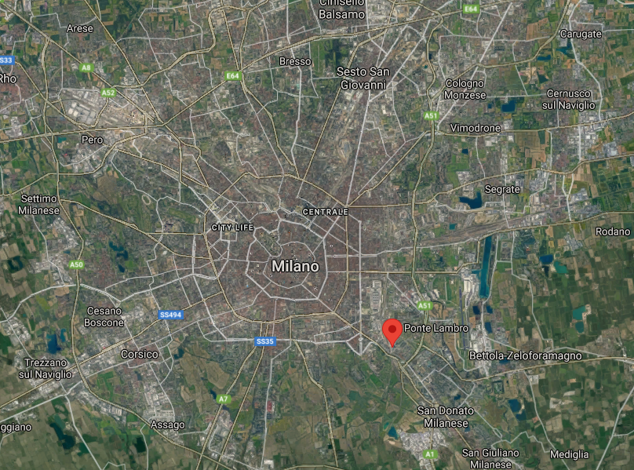

# GEOLOGICAL CONTEXT

## Classification of subsoil units

The geological units present in the outcrop are made up of fluvioglacial and fluvial deposits of the Quaternary age (Cantù Synthem - Upper Pleistocene[1]), mainly characterized by gravels with a sandy matrix and sands with a poorly evolved alteration profile and poorly developed soils, making up the so-called "fundamental level of the plain".

On the basis of the lithological characteristics deduced from the stratigraphy of the wells of the area, three main hydrostratigraphic units are recognized in the subsoil, whose name refers to the 2002 classification proposed by the Lombardy Region, Eni-Agip Division.

Their distribution is summarized in the reference hydrogeological sections passing through the public/private wells of the area and the project area (Figure 1), in which these units follow one another, from the most superficial to the deepest, according to the following scheme:

**A -** Aquifer Group A, with an average thickness of about 50 m, consisting mainly of coarse lithologies with high permeability (pebbles, gravels and sands), with subordinate lenticular intercalations of sandy silts and yellow/brown clays, generally without lateral continuity. The unit hosts the most vulnerable unconfined upper aquifer (first aquifer), currently characterized in the project area by a depth to water of about 16 m from the ground level. This aquifer represents the target of pumping and reinjection wells in the project, therefore in a quite independent circulation with respect to the withdrawal of the wells of the public aqueduct.

**B -** Aquifer Group B, with an average thickness of about 55 ÷ 60 m, consisting of sands and aquifer gravels with metric intercalations of silts and sandy clays characterized by good lateral continuity. The unit hosts intermediate and deep water tables from semi-confined to confined (second aquifer), traditionally captured by the wells of the public aqueduct. By virtue of the presence of continuous low permeability layers, these aquifers are more protected and quite independent from the upper aquifer.

**C -** Aquifer Group C, consisting of alternations of silts and sandy clays with subordinate intercalations of medium-fine sands and gravels. The upper limit of the unit, generally in agreement with the topographical surface, tends to deepen as it proceeds towards the southern sectors. The unit hosts the protected deep confined aquifers, generally reserved for drinking purposes and captured by the deepest filters of the wells of the public aqueduct. At depths> 150 ÷ 160 m from the ground and with an irregular distribution, qualitative problems arise, with the endogenous presence of hydrogen sulphide and high concentrations of iron and manganese.

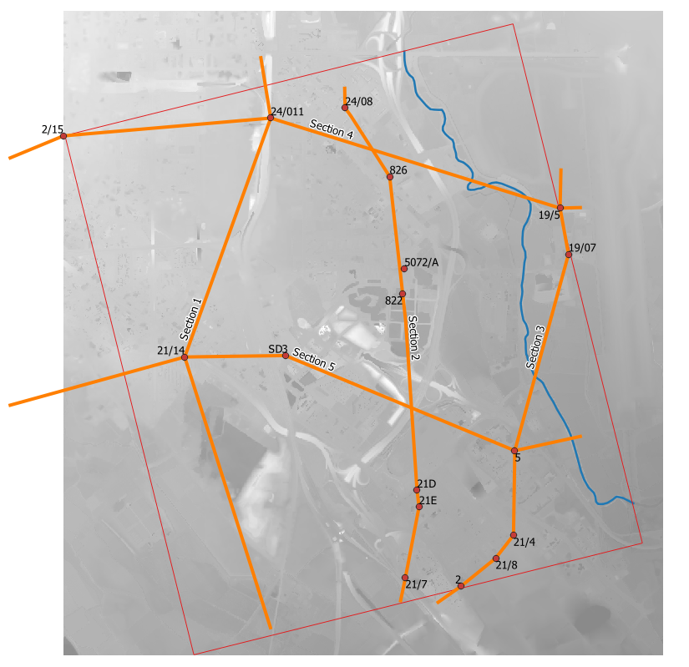

Figure

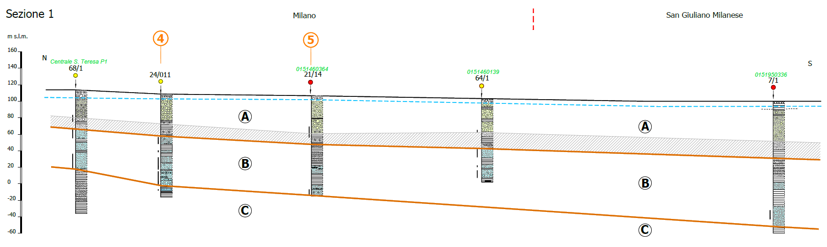

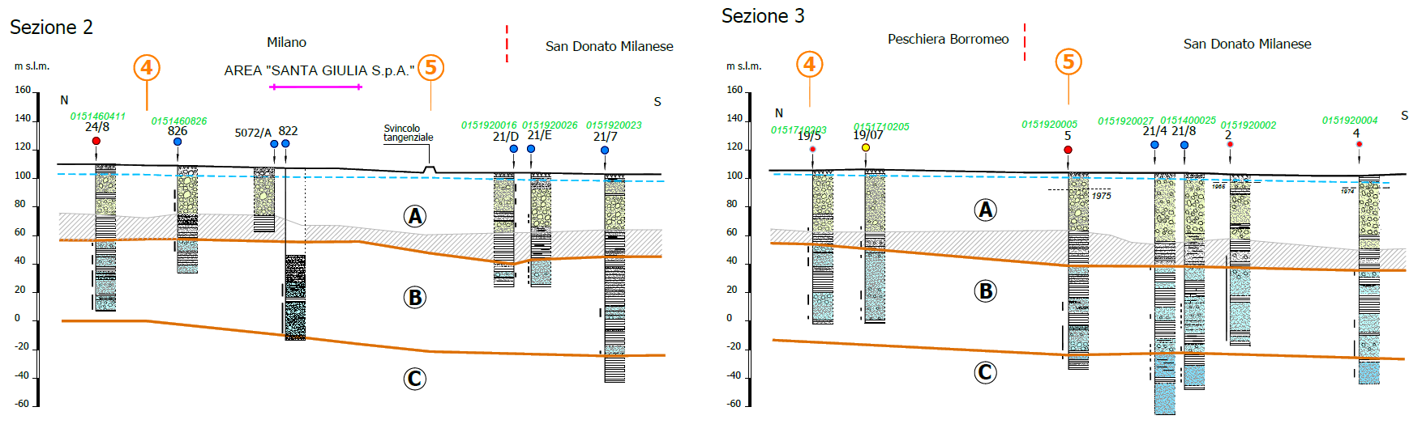

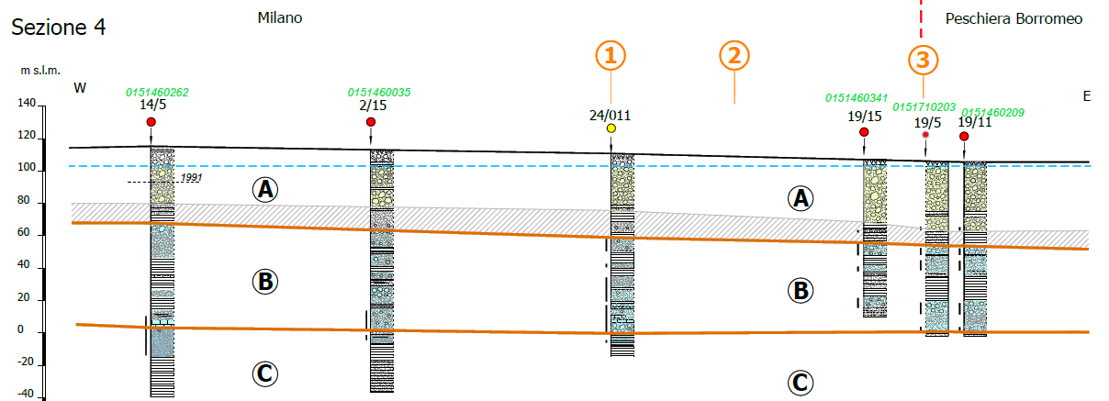

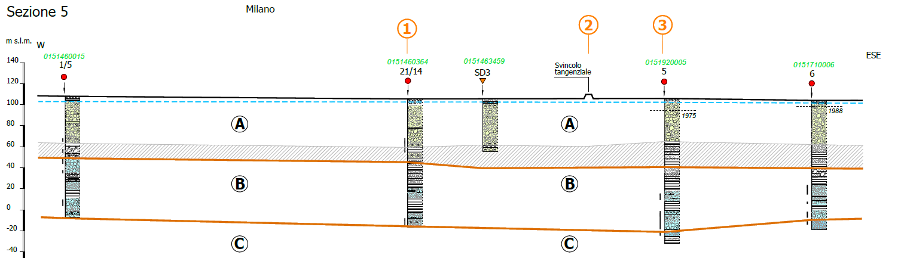

## General piezometric features

The morphology of the piezometric surface of the upper aquifer refers to the level data in September 2017 of the monitoring wells of the metropolitan control network of Metropolitana Milanese SpA[2] (Figure 3).

In the study area, a convergent radial aquifer is highlighted, with altitudes between 114 and 104 m asl and an average hydraulic gradient of 2.8-3.0 ‰ in the northern sectors and 1.7-1.8 ‰ in the southern sectors, with directions of groundwater flow on average oriented NNW-SSE in the central-western sectors and NNE-SSW in the eastern sectors.

The general trend of the piezometric levels graphed below can be deduced from the measurements periodically carried out by Metropolitana Milanese SpA on wells no. 20/6abb and n. 20/7abb and by the Municipality of Milan on piezometer n. 8, monitoring points which are about 1 km from the project area.

The historical series of available data highlights the progressive lowering of the levels characteristic of the 1960s and recorded up to the first half of the 1970s (-20 m), consequent to the over-extraction of the aquifers carried out in that period.

Following the intense rainfall of 1976-77, there is a significant rise in groundwater levels (+13 m), culminating with the relative piezometric maximum of 1978-79, followed by a period of substantial stability, which lasted until 1992.

From 1992 until the end of 1997, there has been a progressive rise in groundwater levels (+6 m), the cause of which is to be found in a series of concomitant factors such as an increase in effective recharge which affected the high and medium plains, the progressive deepening of the aqueduct drinking water collection due to the widespread pollution of the more superficial aquifers (chlorinated solvents, atrazine, etc.) and the decrease in industrial withdrawals in urban and peri-urban areas.



Figure 2- Trend of piezometric heads in 3 monitoring wells in Milan

Since 1998, there has been a new piezometric decrease, interrupted by the rise in levels following the flood events of October 2000 and November 2002. The low rainfall 2003-2007 caused a new lowering of the average piezometric altitudes, albeit to a lesser extent. The increase in rainfalls recorded from 2008-09, with a particular increase in the last three years, led to a generalized rise in levels throughout the metropolitan area, reaching a high level in December 2014. From 2015 to date there has been a new trend of piezometric decrease, albeit of a minor entity, found up to the latest available data (June 2019 well 6abb; February 2020 piezometer n.8).

The dynamics of the groundwater in the last 50 years shows that groundwater withdrawals played an important role in the piezometric trend up to the 1990s; in the most recent withdrawal conditions, which are almost stabilized, the fluctuations are on the other hand linked to the prevalence of natural recharge factors of the aquifers, mainly correlated to the trend of meteoric regimes.

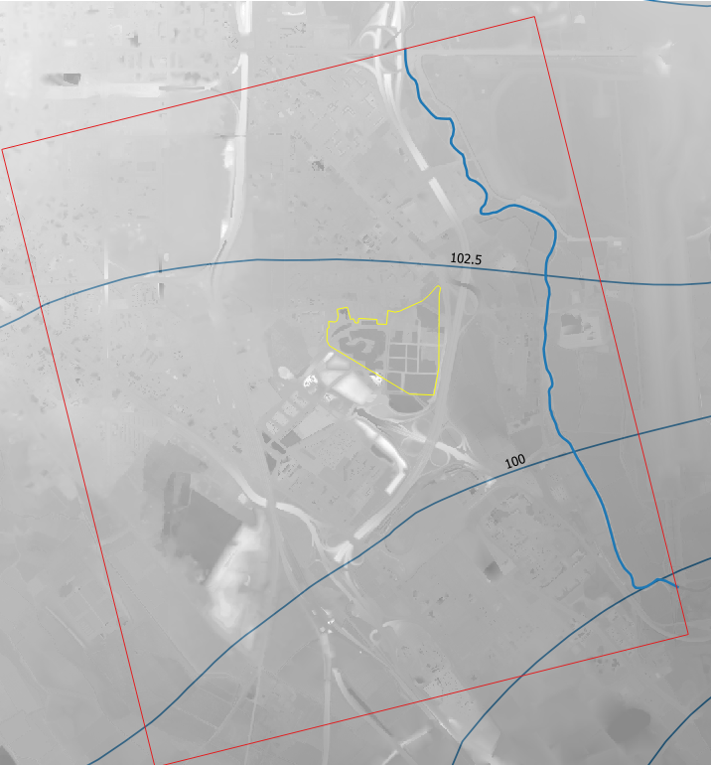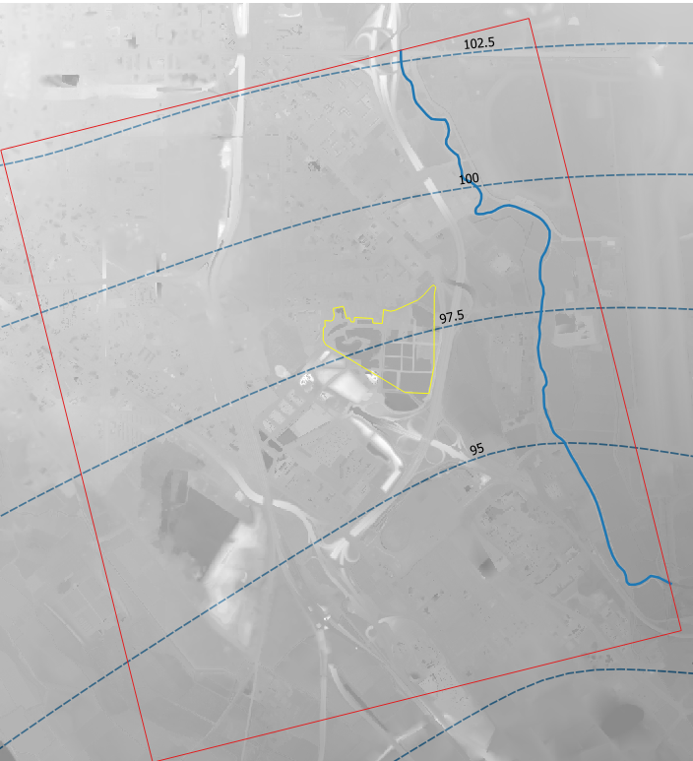

Figure 3 Potentiometric Map, a. first aquifer, b. second aquifer

## The site

The site is located in the southeastern area of Milan. Inside the present property area (Figure 4) there was an important chemical plant, operating since the 60’s. Outside the property, there are two old landfills (Figure 4) connected to the industrial activity.

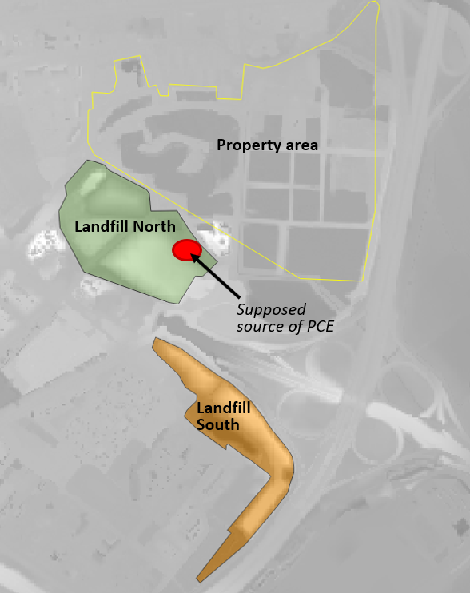

Figure 4

In February 1995, the Environmental Agency initiated a Preliminary Assessment in accordance with the Contaminated sites regulations. Samples from monitoring wells that were installed detected that Tetrachlorethylene (PCE) and other chlorinated solvents were present in groundwater. In 2000, the Regional Authority proposed to list the Site on Register because downgradient private wells contained concentrations of PCE greater than the MCL and because the source area, contamination pathway, and release history of the PCE were unknown. A Remedial Investigation was planned to collect additional data to evaluate the extent of groundwater contamination at the Site. A total of 38 monitoring wells were installed. Most of the wells were installed adjacent locations of known contamination, i.e. nearby the landfills, reaching PCE concentrations of about 50 µg/l in Landfill North; some wells were located upgradient to represent background conditions. A that time, the supposed source of contamination was not clearly detected, but it was thought to be in the SE side of Landfill North (Figure 4).

In July 2019, a new drilling (PROF_5, Figure 5) was performed for building purposes and a concentration of PCE of 31 µg/l was found, hardly justifiable considering the Landfill North source. Additional soil and groundwater samples were collected and 8 new monitoring wells were drilled inside the property; well MW01 had PCE concentrations close to 200 µg/l. Geoelectrical investigations provided information about an underground tank, eventually providing the evidence of another (or maybe of the unique) source of the PCE groundwater contamination.

In September 2019 the full set of the 46 wells was performed providing better details about the contamination distribution and a hydraulic barrier was planned.

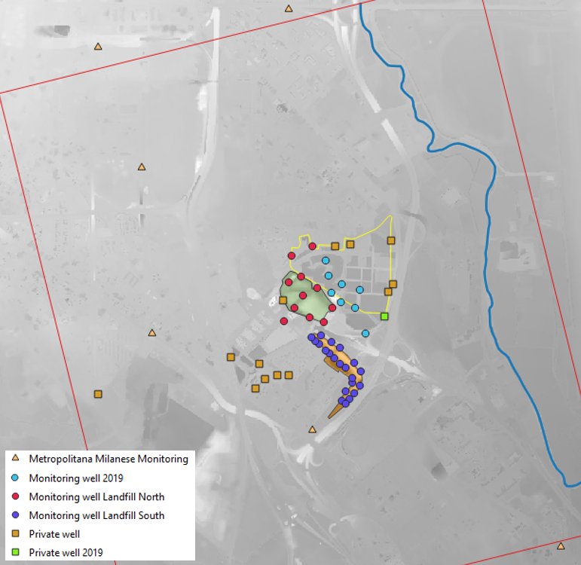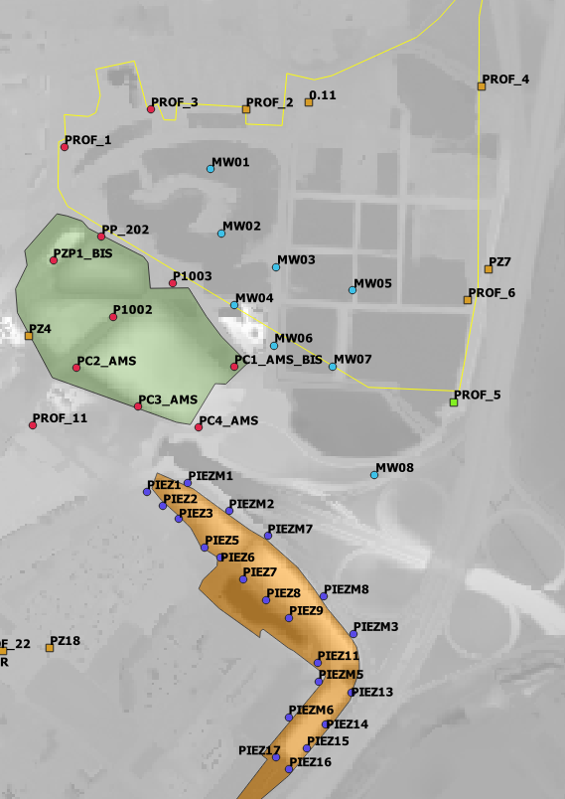

Figure 5

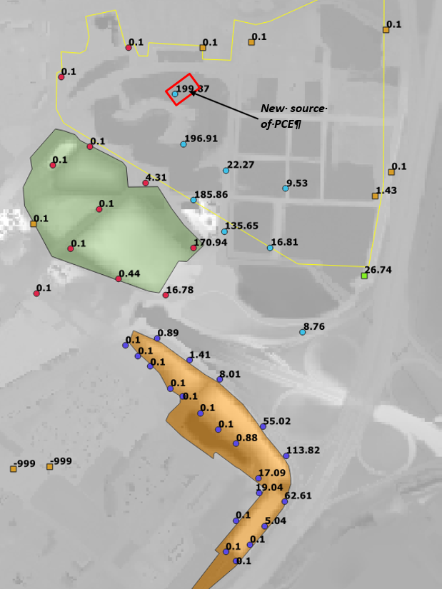

Figure 6

| **ID** | **X**  **EPSG 3003** | **Y**  **EPSG 3003** | **Elevation of top well case**  **(m asl)** | **Aquifer** | **Date** | **Depth to water (m)** | **Heads (m asl)** | **PCE (µg/l)** |
| --- | --- | --- | --- | --- | --- | --- | --- | --- |
| MM164 | 1521510 | 5029751 | 100.6 | First | 15/09/2019 | 3.63 | 96.97 | n.a. |
| MM26 | 1515534 | 5033515 | 114.26 | First | 15/09/2019 | 12.29 | 101.97 | n.a. |
| MM29 | 1516713 | 5032443 | 110.87 | First | 15/09/2019 | 9.43 | 101.44 | n.a. |
| MM32 | 1518066 | 5031555 | 108.23 | First | 15/09/2019 | 6.97 | 101.26 | n.a. |
| MM35 | 1519416 | 5030741 | 105.37 | First | 15/09/2019 | 5.69 | 99.68 | n.a. |
| MM57 | 1517604 | 5033970 | 113.3 | First | 15/09/2019 | 10.82 | 102.48 | n.a. |
| MM91 | 1514369 | 5032229 | 112.64 | First | 15/09/2019 | 10.72 | 101.92 | n.a. |
| MM94 | 1516289 | 5030323 | 109.41 | First | 15/09/2019 | 8.29 | 101.12 | n.a. |
| MM97 | 1517977 | 5032952 | 110.17 | First | 15/09/2019 | 8.54 | 101.63 | n.a. |
| MMS27 | 1519217 | 5034290 | 109.67 | First | 15/09/2019 | 6.55 | 103.12 | n.a. |
| MW01 | 1519536 | 5032168 | 103.015 | First | 15/09/2019 | 1.905 | 101.11 | 199.87 |
| MW02 | 1519558 | 5032040 | 102.883 | First | 15/09/2019 | 1.913 | 100.97 | 196.91 |
| MW03 | 1519668 | 5031972 | 106.974 | First | 15/09/2019 | 6.084 | 100.89 | 22.27 |
| MW04 | 1519584 | 5031895 | 107.705 | First | 15/09/2019 | 6.865 | 100.84 | 185.86 |
| MW05 | 1519822 | 5031924 | 108.646 | First | 15/09/2019 | 7.946 | 100.7 | 9.53 |
| MW06 | 1519663 | 5031814 | 107.564 | First | 15/09/2019 | 6.844 | 100.72 | 135.65 |
| MW07 | 1519782 | 5031772 | 105.758 | First | 15/09/2019 | 5.208 | 100.55 | 16.81 |
| MW08 | 1519866 | 5031553 | 105.335 | First | 15/09/2019 | 5.155 | 100.18 | 8.76 |
| P1002 | 1519337 | 5031872 | 108.73 | First | 15/09/2019 | 7.93 | 100.8 | < 0.1 |
| P1003 | 1519458 | 5031939 | 107.29 | First | 15/09/2019 | 6.43 | 100.86 | 4.31 |
| PC1_AMS_BIS | 1519506 | 5031836 | 107.68 | First | 15/09/2019 | 6.89 | 100.79 | 170.94 |
| PC2_AMS | 1519265 | 5031768 | 106.48 | First | 15/09/2019 | 5.75 | 100.73 | < 0.1 |
| PC3_AMS | 1519388 | 5031690 | 106.9 | First | 15/09/2019 | 6.23 | 100.67 | 0.44 |
| PC4_AMS | 1519511 | 5031648 | 109.31 | First | 15/09/2019 | 8.72 | 100.59 | 16.78 |
| PIEZ1 | 1519406 | 5031519 | 107.24 | First | 15/09/2019 | 6.74 | 100.5 | < 0.1 |
| PIEZ11 | 1519749 | 5031175 | 108.73 | First | 15/09/2019 | 9.06 | 99.67 | 17.09 |
| PIEZ13 | 1519817 | 5031116 | 106.37 | First | 15/09/2019 | 6.78 | 99.59 | 62.61 |
| PIEZ14 | 1519766 | 5031051 | 107.32 | First | 15/09/2019 | 7.75 | 99.57 | 5.04 |
| PIEZ15 | 1519728 | 5031003 | 106.3 | First | 15/09/2019 | 6.69 | 99.61 | < 0.1 |
| PIEZ16 | 1519692 | 5030961 | 106.4 | First | 15/09/2019 | 6.85 | 99.55 | < 0.1 |
| PIEZ17 | 1519665 | 5030985 | 105.44 | First | 15/09/2019 | 5.87 | 99.57 | < 0.1 |
| PIEZ2 | 1519438 | 5031491 | 107.29 | First | 15/09/2019 | 6.82 | 100.47 | < 0.1 |
| PIEZ3 | 1519470 | 5031465 | 108.18 | First | 15/09/2019 | 7.73 | 100.45 | < 0.1 |
| PIEZ5 | 1519523 | 5031407 | 107.69 | First | 15/09/2019 | 7.33 | 100.36 | < 0.1 |
| PIEZ6 | 1519554 | 5031387 | 107.08 | First | 15/09/2019 | 6.78 | 100.3 | < 0.1 |
| PIEZ7 | 1519599 | 5031344 | 107.72 | First | 15/09/2019 | 7.57 | 100.15 | < 0.1 |
| PIEZ8 | 1519646 | 5031301 | 107.52 | First | 15/09/2019 | 7.62 | 99.9 | < 0.1 |
| PIEZ9 | 1519692 | 5031266 | 108.03 | First | 15/09/2019 | 8.19 | 99.84 | 0.88 |
| PIEZM1 | 1519489 | 5031537 | 108.04 | First | 15/09/2019 | 7.57 | 100.47 | 0.89 |
| PIEZM2 | 1519571 | 5031481 | 107.16 | First | 15/09/2019 | 6.83 | 100.33 | 1.41 |
| PIEZM3 | 1519821 | 5031234 | 106.94 | First | 15/09/2019 | 7.19 | 99.75 | 113.82 |
| PIEZM5 | 1519751 | 5031137 | 104.83 | First | 15/09/2019 | 5.25 | 99.58 | 19.04 |
| PIEZM6 | 1519691 | 5031066 | 105.07 | First | 15/09/2019 | 5.57 | 99.5 | < 0.1 |
| PIEZM7 | 1519649 | 5031430 | 106.31 | First | 15/09/2019 | 6.1 | 100.21 | 8.01 |
| PIEZM8 | 1519762 | 5031309 | 106.49 | First | 15/09/2019 | 6.66 | 99.83 | 55.02 |
| PP_202 | 1519315 | 5032033 | 107.97 | First | 15/09/2019 | 7 | 100.97 | < 0.1 |
| PROF_1 | 1519240 | 5032213 | 107.59 | First | 15/09/2019 | 6.43 | 101.16 | < 0.1 |
| PROF_11 | 1519175 | 5031653 | 107.41 | First | 15/09/2019 | 6.75 | 100.66 | < 0.1 |
| PROF_2 | 1519605 | 5032288 | 106.73 | First | 15/09/2019 | 5.51 | 101.22 | < 0.1 |
| PROF_21 | 1518969 | 5031298 | 107.04 | First | 15/09/2019 | 6.84 | 100.2 | n.a. |
| PROF_22 | 1519116 | 5031199 | 107.15 | First | 15/09/2019 | 6.87 | 100.28 | n.a. |
| PROF_3 | 1519414 | 5032289 | 107.12 | First | 15/09/2019 | 5.9 | 101.22 | < 0.1 |
| PROF_4 | 1520081 | 5032335 | 106.08 | First | 15/09/2019 | 4.78 | 101.3 | < 0.1 |
| PROF_5 | 1520023 | 5031700 | 108.49 | First | 15/09/2019 | 8.11 | 100.38 | 26.74 |
| PROF_6 | 1520053 | 5031905 | 108.44 | First | 15/09/2019 | 7.8 | 100.64 | 1.43 |
| PZ_ALER | 1519018 | 5031166 | 106.39 | First | 15/09/2019 | 6.18 | 100.21 | n.a. |
| PZ_IEO | 1516463 | 5029025 | 105.2 | First | 15/09/2019 | 5.21 | 99.99 | n.a. |
| Pz1 | 1517609 | 5031038 | 107.4 | First | 15/09/2019 | 6.73 | 100.67 | n.a. |
| PZ18 | 1519211 | 5031205 | 107.23 | First | 15/09/2019 | 6.32 | 100.91 | n.a. |
| PZ20 | 1518931 | 5031089 | 106.47 | First | 15/09/2019 | 7.07 | 99.4 | n.a. |
| PZ4 | 1519168 | 5031833 | 105.79 | First | 15/09/2019 | 5.02 | 100.77 | < 0.1 |
| PZ7 | 1520094 | 5031968 | 106.98 | First | 15/09/2019 | 6.16 | 100.82 | < 0.1 |
| PZB | 1519732 | 5032303 | 106.77 | First | 15/09/2019 | 5.53 | 101.24 | < 0.1 |
| PZP1_BIS | 1519217 | 5031985 | 107.41 | First | 15/09/2019 | 6.52 | 100.89 | < 0.1 |
| Sp1_PzEst | 1518727 | 5031350 | 107.36 | First | 15/09/2019 | 6.94 | 100.42 | n.a. |

Table 1

## Planned hydraulic barrier

The preliminary hydraulic barrier was designed on the basis of analytical formulas which considered the available information about the source of contamination, the aquifer properties and the hydraulic gradient.

The pumping tests results available in the area are summarized in Table 2 and Figure 7. The frequency distribution of the estimated hydraulic conductivities approximates the log-normal distribution, as evidenced by the QQ-plot in Figure 8. The values that deviate most from the log-normal distribution are those relating to Well P1, estimated on the basis of lowerings in the pumping well itself, therefore affected by head losses which, by overestimating the lowering, tend to underestimate the K values; these values are therefore considered outliers. The representative average value to be taken into consideration for hydraulic conductivity is given by the average of the logarithmic values or by the geometric average of the values as such. This corresponds to 2.3E-3 m/s, within a min-max range that goes from 1E-3 to 5.97E-3 m/s. The geometric mean of transmissivity is 0.06 m2/s. The arithmetic mean of the storage coefficient is 9E-3.

Table 2 Summary of information relating to pumping tests carried out in the area

| **Test** | **Point** | **Q l/s (average)** | **Transmissivity** | **Thickness** | **K** | **S** |
| --- | --- | --- | --- | --- | --- | --- |
| 1 | Well B | 48.7 | 6.17E-2 | 30 | 2.06E-3 | - |
| 1 | Well B | 48.7 | 5.60E-2 | 30 | 1.87E-3 | - |
| 1 | Well B |  | 5.80E-2 | 30 | 1.93E-3 | - |
| 1 | Piezometer |  | 6.80E-2 | 30 | 2.27E-3 | 1.10E-2 |
| 1 | Piezometer |  | 3.65 E-2 | 30 | 1.22E-3 | 3.33E-2 |
| 1 | Piezometer |  | 3.65 E-2 | 30 | 1.22E-3 | 1.70E-2 |
| 2 | Well P1 | 11 | 6.14E-3 | 33.5 | 1.83E-4 | - |
| 2 | Well P1 | 11 | 3.66E-3 | 33.5 | 1.09E-4 | - |
| 2 | Pz1 |  | 1.36E-1 | 33.5 | 4.05E-3 | 5.42E-5 |
| 2 | Pz1 |  | 7.98E-2 | 33.5 | 2.38E-3 | 1.05E-3 |
| 2 | Pz2 |  | 2E-1 | 33.5 | 5.97E-3 | 2.58E-5 |
| 2 | Pz2 |  | 1.61E-1 | 33.5 | 4.81E-3 | 1.4E-4 |
| 3 | PC1-AMS | na | 1 ÷ 3E-2 | 10 | 3E-3  1E-3 | - |
| 4 | PC4-AMS |
| 5 | Piez5 | na | 2.5E-2 | 10 | 2.5E-3 | - |
| 6 | Piez6 |

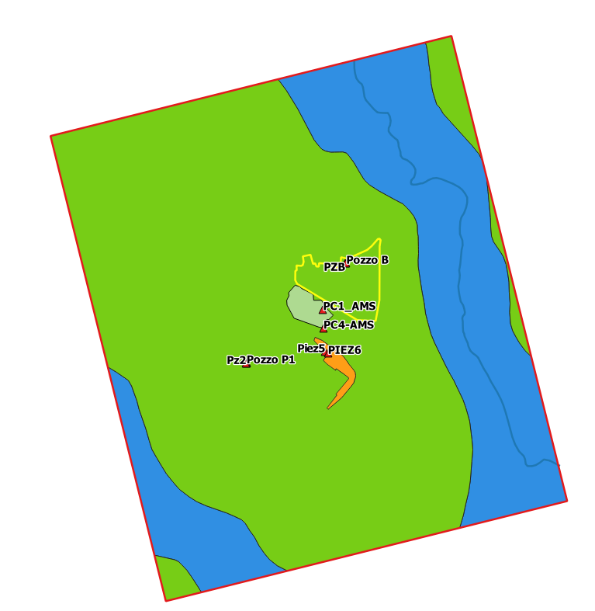

Figure 7 Location of wells and piezometers used in pumping tests in the area and division of the parameter into zones starting from the geological map

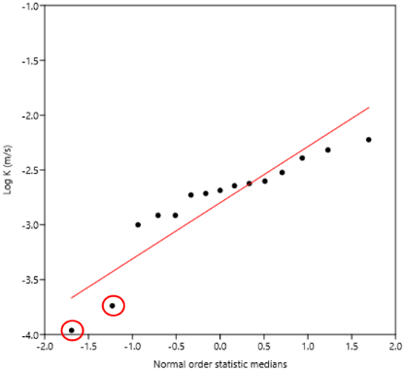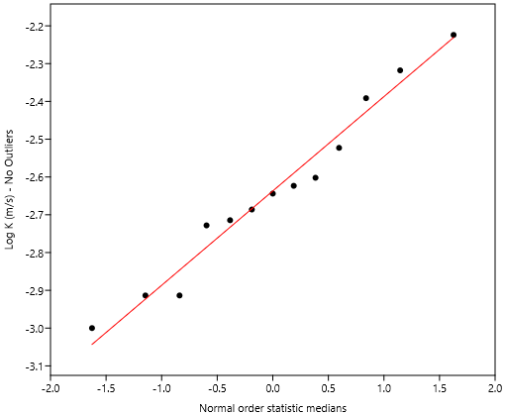

Figure 8 QQ-Plot of hydraulic conductivity, log-transformed values with and without probable outliers (Well P1)

Considering the geometric mean of T= 0.06 m2/s and an average hydraulic gradient of 0.0013, a single well has been proposed to contain the source area inside its capture zone. The Bear equation has been applied, resulting in a pumping rate of 30 l/s (Table 3). The position of the well and extension of the capture zone is shown in Figure 9.

|  |  |
| --- | --- |
| Containment well project | |
| Name | RW1 |
| Position (EPGS: 3003) | 1519614; 5031870 |
| Depth (supposed) | 40 m |
| Method | Rotary drilling without sludge or percussion DN 800 mm till the bottom of the hole |
| Pipe material | PVC |
| Diameter | 406 mm |
| Screen depth (supposed) | 11-38 m |
| Grout | 2-5 m |
| Clay sealing | Compactonit 5-6 m |
| Discharge | 30 L/s |

Table 3 Planned well details

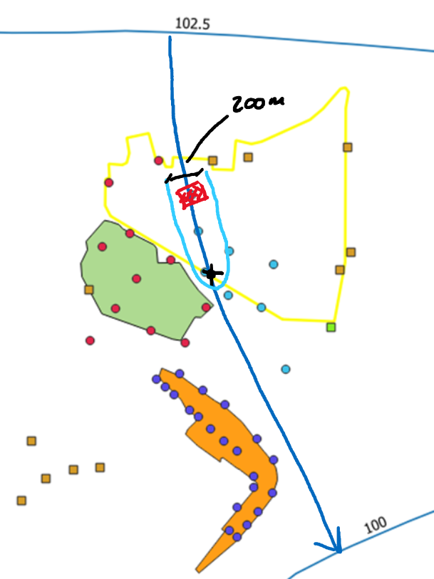

Figure 9

# NUMERICAL MODEL

## Aim of the model

A numerical model was developed to evaluate the proposed design of the hydraulic barrier. Design of this barrier requires evaluation of locations and discharge of extraction well, previously described. Success of its design requires that contaminant concentrations in waters outside the property boundary are below the MCL.

Another concern at this site is whether contamination can migrate to an underlying aquifer where water is extracted for drinking. Previous site characterization studies suggest that the aquitard which separates the upper and lower aquifers will prevent this from happening. However data is insufficient to be sure of this.

Two different versions of the model were set up, according to the evaluation to be performed. The first version, constituted by a single-layer model representing the first aquifer, was used to evaluate the hydraulic barrier effectiveness. A second version, constituted by 3 layers representing the first aquifer, the aquitard and the second aquifer, was used to test the possibility of drinking water contamination.

The overall modelling evaluation included the following activities:

* Calibration against head data recorded in the upper aquifer to explore its ability (or lack of ability) to constrain predictions of contaminant movement (using PEST_HP);
* Simultaneous calibration against both head and concentration data (using PEST_HP);
* Probabilistic assessment of hydraulic barrier efficacy through calibration constrained Monte-Carlo analysis (using PESTPP-IES);
* Exploring the possibility of contamination of the water supply well through direct predictive hypothesis testing.

## Tools used

The implementation of the Geographic Information System functional to the model was carried out in the QGIS environment***[3]***, Open Source desktop GIS software.

For consistency with the source data, the Reference System (CRS) adopted is Monte Mario/Italy 1 (West-fused Gauss-Boaga), uniquely identified by the international code EPSG: 3003.

The geographic information processed starting from the documents acquired by the Client was integrated into the GIS with public domain data distributed by institutional sources; in particular, the following information levels were acquired from external sources:

* Regional Technical Map of the Province of Milan (CTR 10k), in raster format and nominal scale 1:10000;
* Digital Terrain Model (DTM) of the Municipality of Milan, in tiff format and 5 m resolution - 2015 edition;
* Topographic Database DBT 2012 of the Municipality of Milan, in shapefile format;
* Geological Map 1:25000, [Lombardy Region Geoportal](http://www.geoportale.regione.lombardia.it/);
* Geological Map of Italy, Milan, 1:50000, CARG Project;
* Digital orthophoto of the Lombard territory, made in 2003, in tiff format;
* Geognostic investigations from [Lombardy Region Geoportal](http://www.geoportale.regione.lombardia.it/);
* Underground investigations, [ISPRA database](https://www.isprambiente.gov.it/it/banche-dati/banche-dati-folder/suolo-e-territorio/dati-geognostici-e-geofisici);
* Lambro hydrometric level measurements from [Lombardy Region Geoportal](http://www.geoportale.regione.lombardia.it/);
* Meteorological data from the [ARPA Lombardia](https://www.arpalombardia.it/Pages/Meteorologia/Richiesta-dati-misurati.aspx) portal;
* Land use, DUSAF 6.0 of 2018 from [Lombardy Region Geoportal](http://www.geoportale.regione.lombardia.it/);
* Satellite imagery from service [Google Earth](https://www.google.it/intl/it/earth/).

The numerical model described in this document was constructed using the public domain code MODFLOW6*[4]* of the US Geological Survey (Hughes, Langevin, and Banta 2017), for finite difference modeling of groundwater flow and transport. The construction of the model was handled by means of version 8 of the proprietary Groundwater Vistas software*[5]*(Rumbaugh and Rumbaugh 2011) graphic interface only DISU grid. /MODELMUSE – DISV grid

History-matching was undertaken using PEST_HP (Doherty 2020) while the calibration constrained Monte-Carlo analysis involved the use of PESTPP-IES (WHITE et al. 2020)

## Definitions of the study domain

The modeling domain covers an area of approximately 20 km2 as represented in Figure 3. In the EPSG reference system:3003, the coordinates of the vertices are:

* **A:** X = 1516763 m; Y = 5033572 m
* **B:** X = 1520793 m; Y = 5034571 m
* **C:** X = 1517928 m; Y = 5028910 m
* **D:** X = 1521954 m; Y = 5029914 m

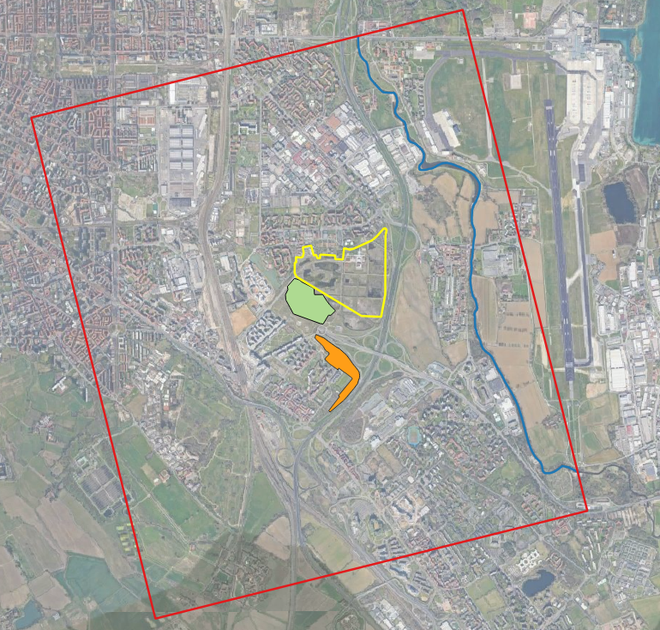

Figure - Model domain

The model grid consists of 18360 cells (Figure 4), of variable width between a maximum of 50x50 m, in the peripheral areas of the model, and a minimum of 12.5x12.5 m, in the area of greatest interest, as shown in Figure 5.

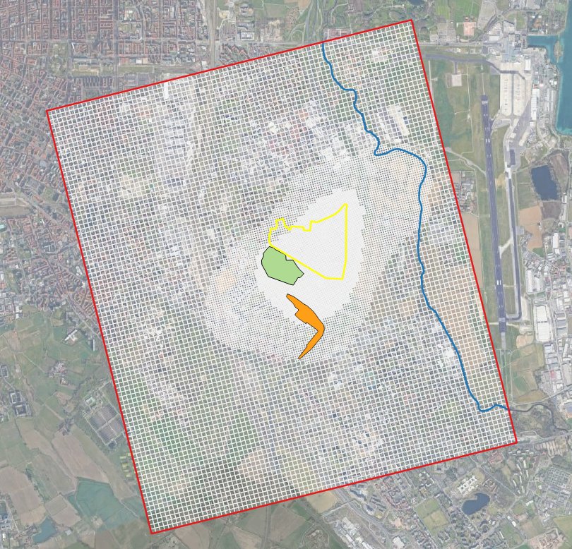

Figure 11- Definition of the unstructured grid

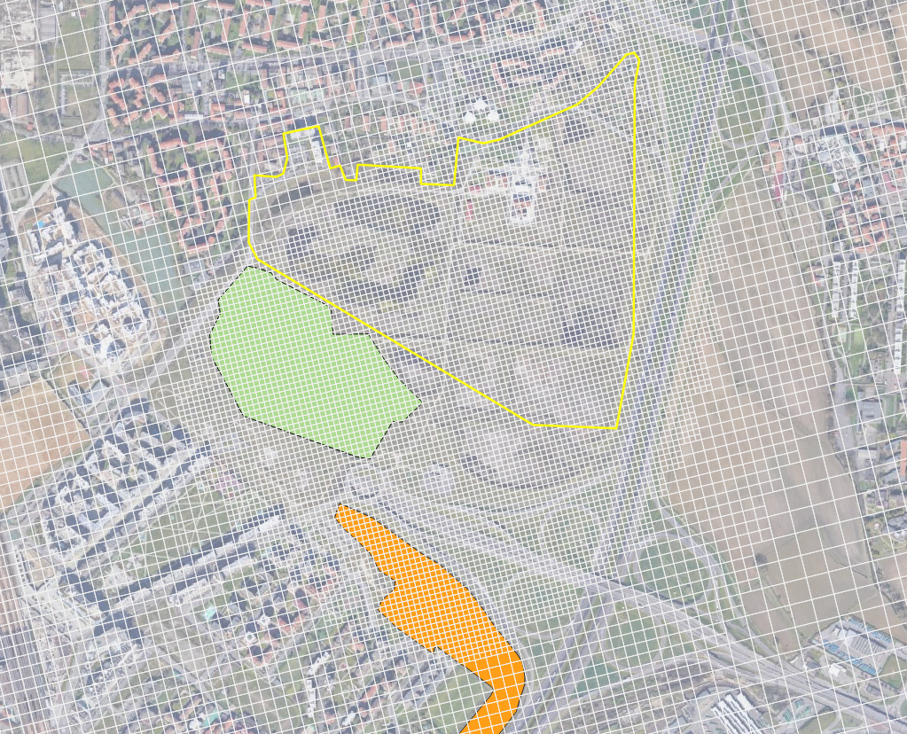

Figure 12- Detail of the areal discretization in the area of interest

The analysis of the available stratigraphic data made it possible to define a vertical discretization within the domain which includes 3 layers, distinguishable but not hydraulically independent, to represent the first two Aquifer Groups (A and B) and the transition between two.

This vertical discretization of the study domain allows the diversification of the main hydrodynamic properties; a comparison between the stratigraphic relationship schemes proposed by the reference literature and the scheme implemented in the model is proposed in Table 4.

Table 4 - Comparison between the stratigraphic scheme of literature and that adopted in the model

|  |  |  |  |
| --- | --- | --- | --- |
| ENI-Lombardy Region classification  (2002 and 2005) | | Schematization adopted in the model | |
| Unit | Description | Levels | Description |
| **Group A** | The unit in question is characterized by the clear prevalence of coarse lithotypes with clayey lenses of limited thickness and areal extension; in current terminology it is identified as "First Aquifer" as it forms the reservoir rock of the free aquifer of the Milanese sector. | **Layer 1** | Gravels and coarse sands with a coarse sandy matrix with subordinate sandy levels from medium to coarse; locally present plurimetric levels of clays and silty clays. |
| **AB transition** | Poorly permeable levels made up of silts and clays, which limit exchanges between the free aquifer of the first aquifer and that contained in the second aquifer. | **Layer 2** | Levels of silts and clays that limit the exchanges between the two layers. |
| **Group B** | It consists of an alternation of gravelly-sandy, sandy and silty-clayey deposits, sometimes with conglomeratic or arenitic cemented lenses. It forms the basal part of the "Traditional Aquifer" and is identified under the hydrogeological aspect as "Second Aquifer". | **Layer 3** | Gravels in sandy matrix, sands, conglomerates with levels of fine clayey silty sediments. |

The surface placed at the top of the first layer was constructed by assigning the value of a smoothed version of the 5x5 m DTM of the Lombardy Region to the height of the top of each cell of the first layer.

For the reconstruction of the bottom of layers 1 and 2 (which respectively represent the top and the bottom of the Transition Unit AB) and of the bottom of layer 3 (which represents the bottom of the model), the elevations derived from the interpretation of stratigraphy of boreholes, public and private wells or piezometers available for a much larger area than the one modeled. The dataset of the elevations of the stratigraphic contacts was interpolated with geostatistical tools in order to obtain continuous surfaces, usable at a modeling level.

Although the number of stratigraphies reaching depths greater than 25 m within the site is limited, a certain regularity of the surfaces is assumed, as widely reported in the literature. This does not exclude the possibility of local variations in the thickness of the hydrogeological units in points not covered by information.

The temporal discretization provided a first version of the model consisting of a single stress period in steady state conditions reproducing September 2019, functional to test the numerical and structural stability of the model. In the scenarios, different time frames were used in transient regime.

## Initial parameters assigned

The initial hydrogeological parameters were assigned based on information from the Geological Map 1:25000, 1:50000 CARG and surveys available for the site and its surroundings. Two different areas are recognized, the first interesting the whole investigated site (LCN, Cantù Synthem), the second relating to alluvial deposits of the Lambro river (POI, Po Synthem). For the first area, the estimates of hydraulic conductivity from pumping tests are summarized in Figure 7 and Table 2.

After a first calibration cycle with uniform K zones, in Zone 1 the information deriving from the pumping tests and from the stratigraphies present in the area was introduced (Figure 8). As better explained in the following paragraphs, the qualitative information was introduced as Prior information associated with Pilot Points which, together with the observed head values, enriched the dataset of the constraints to be respected in the estimation of the parameters. Four initial settings of hydraulic conductivity associated with Pilot points (PP) have been distinguished:

* PP_0: points for which neither stratigraphic information nor extraction tests are present;
* PP_SGL: stratigraphies with predominance in the saturated thickness of slightly silty sands, associated with gravel or not;
* PP_SG: stratigraphies with predominance in the saturated thickness of sands associated with gravels, absence of silty fraction;
* PP_MIX: stratigraphies with alternating saturated thickness of the two previous ones (with comparable thicknesses).

Regarding the second area, no specific information is available. From the analysis of the available stratigraphies, a comparison was made by comparing the stratigraphies of the wells in which the pumping tests were carried out; PP falling in that area were all assigned an initial value equal to 4.5E-3 m/s (PP_SG).

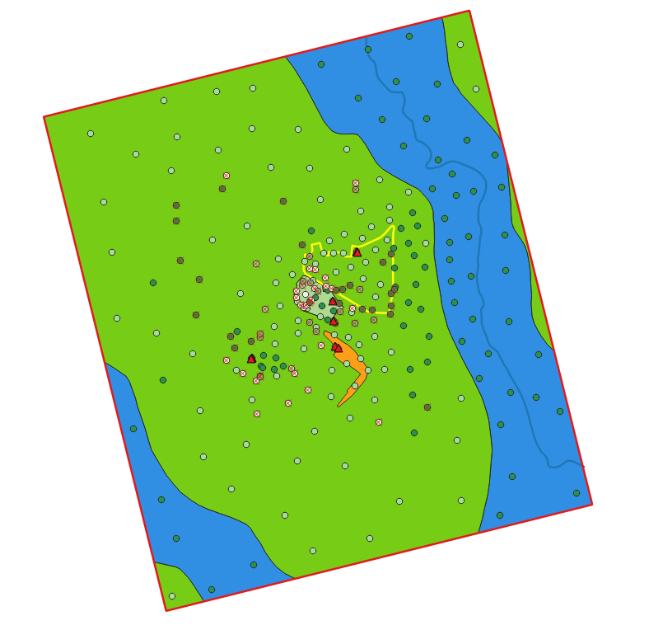

Figure 13 Points with information deriving from pumping tests (red triangles), stratigraphies (x) carried out in the characterization phase (ERM, Ref. 012169, 2011) and from the Geoportal of the Lombardy Region (data downloaded: July 2020)

The initial values assigned to the hydrogeological units and to the Pilot Points are summarized in Table 6.

Table 6- Initial values of the hydrodynamic parameters; *Values used as Prior information

| Layer | Zone | Description | KH  (m/s) | KV  (m/s) | Storage |
| --- | --- | --- | --- | --- | --- |
| 1 | 1 | PP_0 (info absent) | 2.3E-03 | 1/10 KH | 9E-3 |
| PP_SGL (sand and gravel with silt) | 1.5E-03* |
| PP_MIX (alternation) | 2.6E-03* |
| PP_SG (sands and gravels) | 4.1E-03* |
| 4 | Alluvial deposits River Labro | 4.5E-03 |
| 2 | 2 | Aquitard | 1E-08 | 1E-5 |
| 3 | 3 | Second aquifer | 2.3E-03 | 1E-5 |

The recharge that insists on the area was estimated considering the average annual Precipitations P recorded at the Juvara weather station (ARPA Lombardia, 2017) during the period between 2014 and 2017. By applying the general formula of the hydrological balance, we proceeded with the calculation of the overall runoff DG or water surplus, according to the relationship:

P-ETR = I + R

DG = I + R

where:

* P is the value of annual rainfall, in mm/y
* ETR is the real evapotranspiration, in mm/y
* I is the infiltration, in mm/y
* R is the runoff, in mm/y

The real evapotranspiration ETR (in mm/y) was therefore estimated with the Turc method:

$$ETR=\frac{P}{\sqrt{0.9+\frac{P^{2}}{L^{2}}}}$$

with L function of the temperature T according to the relation

$$L=300+25T+0.05T^{3}$$

Starting from the overall outflow DG, the infiltration I was calculated by applying the potential infiltration coefficient (CIP) obtained from the literature (Celico 1988), (Civita 2005), coupled with land use assessments.

$$I=\left(P-ETR\right)*CIP$$

In Table 7 the categories of land use present within the domain are reported, as resulting from the processing of DUSAF 6.0 data (Destination of Use of Agricultural and Forest Soils). A corrective factor was applied to the CIP for each category. The recharge obtained, equal to infiltration I, is between about 250 (CIP = 80%) and 0 mm/y (CIP = 0%).

Table 7 - CIP values assigned to the DUSAF land use categories for the calculation of I

| Land use category from DUSAF | CIP (%) |
| --- | --- |
| Public and private service systems | 0 |
| Industrial, artisanal and commercial settlements | 0 |
| Technological systems | 0 |
| Road networks and ancillary spaces | 0 |
| Scattered residential fabric | 0 |
| Dense residential fabric | 0 |
| Construction sites | 0 |
| Degraded areas not used and not vegetated | 0 |
| Discontinuous residential fabric | 50 |
| Railway networks and ancillary spaces | 50 |
| Sparse and nucleiform residential tissue | 50 |
| Sport facilities | 50 |
| Simple arable land | 50 |
| Arborated arable land | 50 |
| Protected horticultural crops | 50 |
| Open field flower and nursery crops | 50 |
| Wood arboriculture | 50 |
| Natural water basins | 50 |
| Artificial reservoirs | 50 |
| Parks and gardens | 70 |
| Cascine | 70 |
| Uncultivated green areas | 70 |
| Family gardens | 70 |
| Bushes in abandoned agricultural areas | 70 |
| Vegetation of inland areas and peat bogs | 70 |
| Broad-leaved woods with medium and high density governed by coppice | 80 |
| Low-density deciduous woods governed by coppice | 80 |
| Vegetation of the raised embankments | 80 |

The data relating to I of each land use zone have been converted into the Recharge boundary condition (RCH, in m/s) according to the different zones represented in Figure 9.

Table 8 - Terms of the average budget for the period 2014 and 2017 considered in the model

| Period | T medium  (° C) | P  (mm/y) | ETR  (mm/y) | Average annual DG  (mm/y) | CIP  area | RCH  (mm/y) |
| --- | --- | --- | --- | --- | --- | --- |
| 2014 - 2017 | 12.3 | 869 | 556 | 313 | 0 | 0 |
| 2014 - 2017 | 12.3 | 869 | 556 | 313 | 30 | 94 |
| 2014 - 2017 | 12.3 | 869 | 556 | 313 | 50 | 156 |
| 2014 - 2017 | 12.3 | 869 | 556 | 313 | 70 | 219 |
| 2014 - 2017 | 12.3 | 869 | 556 | 313 | 80 | 250 |

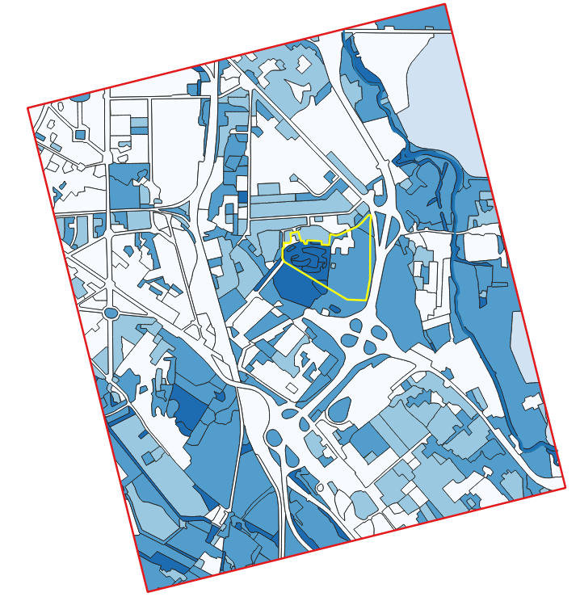 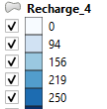mm/y

Figure 14 - Distribution of the recharge values attributed to the cells of the first layer of the flow model

## Boundary conditions

The choice of specific datasets to be used for the definition of the different boundary conditions (BC) was dictated by the following factors:

* spatial coverage of the study domain (highest possible amount of validated data);
* temporal coherence (simultaneity) of the datasets relating to different BCs.

In order to reproduce the regional flow, the model boundaries were defined by imposing General Head Boundary (GHB) boundary conditions on layers 1 and 3 (Figure 10). The values assigned to the GHB conditions were entered taking into account the results of the September 2019 measurement campaign and the average trend of the First and Second aquifers starting from the piezometries available on a large scale.

On the east side of the model, the First aquifer could be in communication with the River Lambro, which is inserted in the model as a RIVER condition (Figure 10). The levels of the watercourse were taken from LIDAR quotas and compared with the hydrometer upstream of the model area (Stazione 869 Milano v. Feltre, Figure 11):

* Hydrometer altitude: average level September 2019: 69.05 cm from hydrometric zero (115.1 m asl) = 115.79 m asl;
* LIDAR altitude in correspondence with the Hydrometer: 116.2 m asl.

The LIDAR heights inserted in the model are therefore adjusted by subtracting 0.4 m to reproduce plausible levels for September 2019. The considered river elevations reflect the small jumps present along the watercourse in the modeled stretches and related to the two points shown in Figure 12.

Figure 15 Boundary Conditions inserted in the modeling domain

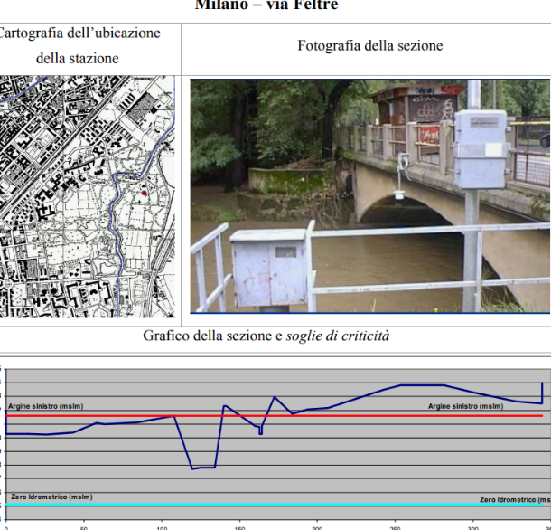

Figure 16 Milano Via Feltre sul Lambro station, used for check and adjustment of LIDAR elevations

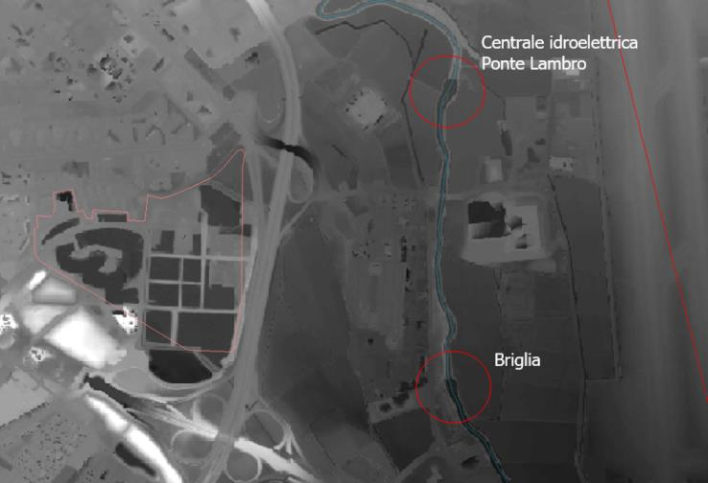

Figure 17 Hydraulic works falling within the model

The modeled domain is characterized by the presence of numerous extraction wells. The information available, although approximate, has been included in the model in order to better represent the terms of the water balance affected by anthropogenic factors.

Public, private and geothermal wells were considered based on the available data. Where information regarding the screens was available, this was introduced into the model by associating the top and bottom of the screen in m asl.

The right placement of the filtering sections of the wells in relation to the vertical discretization of the model, allowed to associate the pumpings with the layers where they actually fall, according to the thickness and properties of the layer itself. The flow rates of the wells for which there was no information on the screens were cautiously assigned to the first layer (First aquifer).

## Flow Model calibration

## XXX

## Transport Model calibration

# CONCLUSIONS

theme of a module 4 course

Based on the obtained results, there are some indications that the discovered PCE source could not be the only one. It is strongly recommended to further investigate the site after a preliminary use of inverse methods to explore the existence and location of a second contaminant source.

# REFERENCES

Celico, P. 1988. *Prospezioni Idrogeologiche*. Liguori.

Civita, M. 2005. *Idrogeologia Applicata e Ambientale*. CEA.

Doherty, John. 2020. *PEST_HP, PEST for Highly Parallelized Computing Environments*. Brisbane: Watermark Numerical Computing.

Hughes, Joseph D., Christian D. Langevin, and Edward R. Banta. 2017. *Documentation for the MODFLOW 6 Framework*. Reston, VA.

Rumbaugh, Douglas B., and James O. Rumbaugh. 2011. “Groundwater Vistas.” 262.

WHITE, Jeremy, Randall HUNT, Michael FIENEN, and John DOHERTY. 2020. “Approaches to Highly Parameterized Inversion: PEST++ Version 5, a Software Suite for Parameter Estimation, Uncertainty Analysis, Management Optimization and Sensitivity Analysis: U.S. Geological Survey Techniques and Methods 7C26.”

1. Data source: New geological map of Italy at 1: 50,000 scale - CARG Project - Lombardy Region
2. Data from Metropolitana Milanese SpA - Integrated Water Service.
3. https://www.qgis.org/it/site/
4. <https://www.usgs.gov/software/modflow-6-usgs-modular-hydrologic-model>
5. http://www.groundwatermodels.com